

**BTC2202 / ICS2014 : Computer Organization and Architecture**

**Assignment #2: Computer Organization and Architecture(Number Systems).**

Lusiji Lyvia Msimbi, 120190

**Question 1**

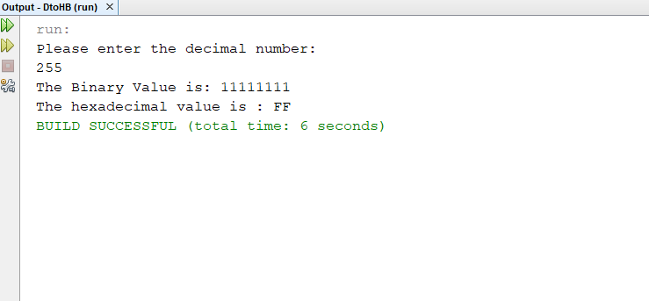

**Question 2**

